Item  1.  2.  3.  4.  5.  6.  7.  8.  9  10.  11.  12.  13.  14.  15.  16. | Councillor Maggie Dunn chaired the meeting along with Councillors Gwyn James, Jenny Stone, Elaine Read, Andy Baker and Peter Fisk.  1 member of the public, Councillor Rebecca Hopfensperger and the Parish Clerk were also present.  Chairmans welcome, reminder about the filming of meetings and to receive apologies for absence  Councillor Maggie Dunn welcomed everyone to the meeting and reminded everybody present that the meeting maybe recorded. Apologies were received and accepted from Councillors David Clarke and Sarah Broughton.  To receive members declarations of interest  There were no declarations of interest or requests for dispensation.  Open public session  There were no comments or questions raised in the open public session.  To receive a report from County Councillor Rebecca Hopfensperger  Councillor Hopfensperger advised that there is a full council meeting of West Suffolk Council on 16/7/24 where the following items are on the agenda.  - Investment proposal for the leisure centre, addressing maintenance predominantly.  - A business case proposal for the Olding Road site to provide a trampoline and virtual reality park.  - Upgrade of the NHS logistics building which could then be divided and rented out.  - A business case for planning permission for business starter units on the Anglia Lane site.  Councillor Hopfensperger advised that Great Barton were not alone in complaining about the lack of grass cutting and the hit and miss approach which seems to have been adopted. She asked that we continue to report using the reporting tool on the website and let her have the numbers to chase. She will request that School Road be cut and may be able to fund some skirting back of the pavements from her highways budget.  To receive a report from Borough Councillor Sarah Broughton  Councillor Sarah Broughton sent her apologies.  Update on the Triangle Development.  Philip Reeve advised that he had emailed West Suffolk Council asking for a meeting with Cliff Waterman but as yet had not had a reply. A reply had been received about meeting the Barley Homes and Philip suggested a party of 3 attend the meeting to include one member of the Parish Council. The Clerk will advise who is available to attend.  To sign the minutes of the Council meetings held on Monday 17th June 2024 to stand as an accurate record of the meeting  Councillor Gwyn James proposed acceptance of the minutes of the Council meeting on 17th June 2024 to stand as an accurate record of the meeting. Seconded by Councillor Elaine Read unanimous decision from those present at the meetings. The minutes were then signed as a true record.  To sign the planning meeting minutes on 8th July 2024 to stand as an accurate record of the meeting and consider the completed and approved planning applications from West Suffolk Council  Councillor Gwyn James proposed acceptance of the minutes of the planning meeting on Monday 8th July 2024 to stand as an accurate record of the meeting. Seconded by Councillor Elaine Read, unanimous decision from those present at the meetings. The minutes were then signed as a true record. There were no completed planning applications for the period.  FINANCE  a) Payment of accounts and outstanding invoices  Approval of Payments schedule for July 2024 resolved. The Council resolved to pay the following accounts. Proposed Councillor Andy Baker, Seconded Councillor, Maggie Dunn unanimous decision.  Internet banking transactions entered by the Clerk verified by Councillor Gwyn James, verified and released by Councillor Maggie Dunn.  July 2024 Payment Schedule  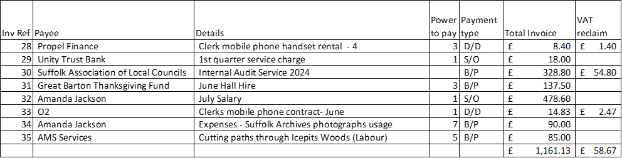  b) The Financial report from the Responsible Financial Officer including details of bank balances  as at 9/7/2024, Bank reconciliation for June/July 2024, reserve budgets and spending against  them and any items arising from risk assessments which had been circulated. There were no  items arising from the report and no questions.  c) There were no questions about the list of Councils aggregate receipts and payments for the  quarter.  d) Council reviewed the actual spend to date against the budget, there were no questions.  Responsible Financial Officer’s Financial Report July 2024  Bank balances at 9th July 2024  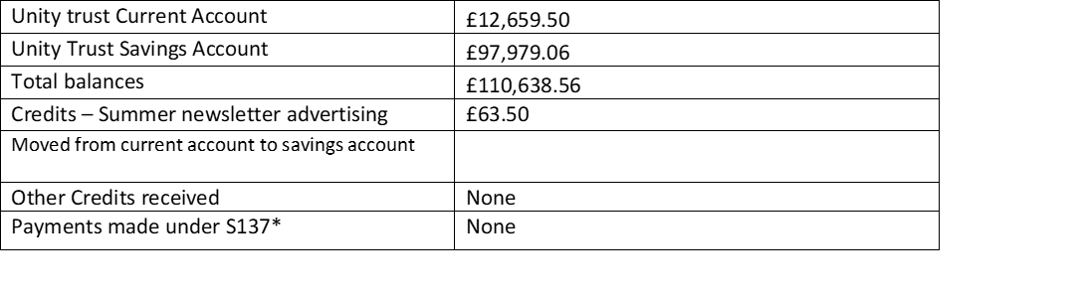  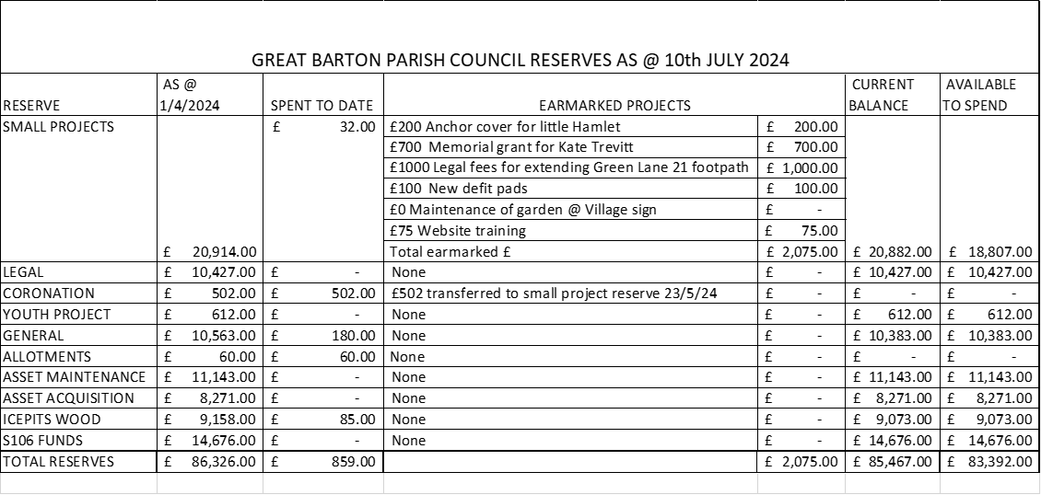  Continuation of the Annual Governance and Accountability Return 2023/24  - A review of the Financial Regulations was postponed until the September meeting.  - The Council reviewed the asset register and approved.  - The Council reviewed the Internal Auditors report and were happy for the Clerk to action the two recommendations.  Non-financial items carried forward from previous meetings  - Cox Lane to Icepits wood footpath – there are no updates.  - Village Gates – Councillor James is waiting for an additional quote from SCC.  - Newsletter – The Clerk advised that the editor has resigned due to lots of commitments, Council agreed that Gipping Press can type set the summer newsletter at a cost of upto £140 to be paid from the General reserve. Councillor Maggie Dunn proposed, seconded by Councillor Gwyn James, unanimous decision. The Council thanked Jan for all her hard work over the last number of editions.  - Playground – The Clerk is monitoring the area for mole activity and will action treatment when required.  - Elm Meadow - Councillor Maggie Dunn will organise a meeting in August to discuss the proposed plans.  Chairmans and Councillor reports  There were no reports.  Correspondence not covered elsewhere on the agenda  - Reports received about a vender selling coffee and cake on Conyers Way were discussed, the Clerk will report to West Suffolk Council.  - The Clerk has updated a resident on the progress of the Village Gates.  - BTS advised they will be trimming the trees on the triangle at the church because they are touching power lines.  - 2 calls and 1 email received about the condition of the grass cutting and verges around the village.  - A request to use the Parish Council noticeboards for general notices for events within the village.  Items to be carried forward to the next meeting  Amendment to the Financial Regulations,  Closing of the public session  Date of the next meeting – Monday 16th September 2024  There being no further business the meeting finished at 9.35pm.  …………………………………………………………………………………………………… sign and date  ……………………………………………………………………………………………………. Print name  Chairman  Signed as confirmation that they are a true record. | Action  RH  AJ  AJ  AJ  AJ  AJ  MD  AJ  AJ

